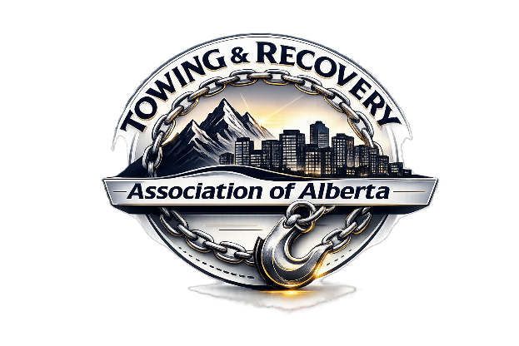
Wayne POPOW – CENTRAL DISTRICT DIRECTOR

Wayne is a highly respected towing and recovery professional with over 30 years of hands-on experience as an operator in the industry. He holds an 8/9R WreckMaster certification and currently serves as the General Manager of Towing and Recovery Operations for Popow & Sons Body Shop Ltd. Founded in 1945 by his grandfather, Victor Popow, Popow & Sons is a third-generation family business with deep roots in Alberta’s towing, recovery, and collision repair industries. Wayne has played a key role in modernizing and expanding the towing and recovery division while maintaining the values of professionalism, safety, and service excellence that the company was built on.
Wayne is a founding member of the Towing & Recovery Association of Alberta (TRAA) and serves as the Central Director, actively contributing to industry standards, operator education, and advocacy across the province. In recognition of his expertise, leadership, and commitment to the profession, Wayne was named a WreckMaster Top 10 award recipient in 2023, an honor recognizing excellence among towing and recovery professionals across North America

