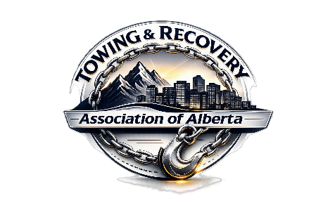
Garry LEACH - PRESIDENT
GARRY is presently in his 56th year of participation in the towing and recovery industry. He gained his first experience with towing while working after school and on weekends in a service station managed by his Father and that also operated a tow truck. The knowledge and experience Garry gained from his father who had also operated a breakdown lorry for the Canadian Military in WWII led him to become passionate about towing. In 1969 he purchased a brand-new Chevy C30 with a Holmes 440 wrecker and while he did not have the full amount required for the down payment of this first truck, he convinced the dealer to accept half and give him 2 weeks to pay the balance. He immediately commenced business as United Towing Services and returned after less than a week to pay the remaining balance.
In only 6 short years he grew his operation to 55 units and secured major contracts with the Provincial vehicle insurance corporation and THE WINNIPEG POLICE DEPARTMENT providing service to over 110,000 calls per year.
During his first decade of operations, he was heavily involved in the Towing Division of the MANITOBA AUTOMOTIVE TRADES ASSOCIATION serving terms as a director and President. As a proud member of the association, he worked tirelessly to improve the image and professionalism of the towing industry and was instrumental in writing a draft for tow truck regulations in the PROVINCE of MANITOBA.
In 2002 Garry relocated his business to be closer to his children. From CANMORE, ALBERTA he commenced operations that later included several other ALBERTA locations. In only a short period of time he was providing full services to almost 350 miles of The TRANS-CANADA HIGHWAY and providing services to 8 detachments of THE ROYAL CANADIAN MOUNTED POLICE.
Garry has provided significant annual contributions to many community groups including the CANMORE FOLK FESTIVAL, CANMORE HIGHLAND GAMES, CANMORE MINERS ASSOCIATION, CANMORE MUSEUM, CANMORE FIRE & RESCUE SERVICE, CANMORE PARTY (Prevent Alcohol & Risk Related Trauma in Youth) PROGRAM and CANMORE CANADA DAY activities. He is a member of the BANFF/LAKE LOUISE TOURISM ASSOCIATION and has served as the past President of BOW VALLEY CRIME STOPPERS ASSOCIATION and is a former member of the CANMORE ROTARY CLUB.
Garry is a founding member and the current President of THE TOWING & RECOVERY ASSOCIATION OF ALBERTA which works to improve the towing industry through lobbying and initiatives. He has and continues to work towards improving major and significantly critical areas of the industry.
Garry has been featured on DISCOVERY CHANNEL’S television series HIGHWAY THRU HELL and has provided consulting and technical contributions to the writers and producers of the show since its beginning in 2012.
In 2013 GARRY was critically injured in a work-related incident and later became the recipient of The AMERICAN TOWMAN SILVER STAR for his perseverance at over coming adversity from his life-threatening injuries and by returning to the towing and recovery industry. The award was presented to him at The AMERICAN TOWMAN SHOW in BALTIMORE, MARYLAND in November 2014.
In September 2016, GARRY was honoured with the highest award in the towing and recovery industry when he was inducted into THE TOWING & RECOVERY HALL OF FAME in Chattanooga, Tennessee, USA.

